**Scientific Report on Predictive Maintenance**

**Abstract/Introduction**

Predictive maintenance has emerged as a transformative approach to equipment reliability, leveraging data analytics and machine learning to anticipate potential failures before they occur. In industrial settings, unplanned downtimes can lead to significant operational disruptions and financial losses. This report delves into the exploration of predictive maintenance strategies, focusing on the integration of Exploratory Data Analysis (EDA) and machine learning techniques to address these challenges.

The dataset used in this study comprises operational parameters, such as air temperature, rotational speed, and torque, along with tool wear data. These features were analyzed to identify patterns and correlations that signify impending failures. By employing robust machine learning models, the study aims to predict failure types, enabling proactive maintenance and minimizing disruptions.

A comprehensive review of the literature reveals the increasing adoption of predictive maintenance due to advancements in sensor technologies and data-driven models. Existing studies underscore the critical role of domain expertise in refining these models, alongside the application of algorithms such as logistic regression, random forests, and gradient boosting. Explainable AI tools have further enhanced trust and interpretability in predictive systems, making them more practical for industrial applications.

This report highlights the methodology used to preprocess and analyze the dataset, including handling data imbalances and engineering meaningful features. The performance of various classification models is evaluated using metrics like precision, recall, and F1-score. The findings demonstrate the efficacy of random forest and gradient boosting models in accurately predicting machine failures. Furthermore, this study identifies key predictors, such as torque and tool wear, which significantly influence failure probabilities.

By integrating these findings, the report not only showcases the potential of predictive maintenance in reducing operational inefficiencies but also sets the stage for future enhancements, such as incorporating real-time data and advanced deep learning techniques. This comprehensive approach paves the way for more resilient and cost-effective maintenance systems in diverse industrial contexts.

**Literature Review**

The increasing reliance on predictive maintenance stems from its potential to prevent costly equipment failures and optimize maintenance schedules. Key studies have emphasized the integration of sensor technologies and machine learning models to enhance fault detection and prediction. For instance, researchers have explored the use of logistic regression for simple, interpretable models and random forests for handling complex feature interactions. Gradient boosting and deep learning techniques have been instrumental in achieving high accuracy and robust predictions.

Recent advancements have also highlighted the importance of feature engineering, with studies demonstrating that derived features like moving averages or lagged variables can significantly improve model performance. Explainable AI tools, such as SHAP values and LIME, have been increasingly used to interpret machine learning predictions, enabling domain experts to understand and trust the models.

Moreover, the literature underscores the importance of addressing data imbalance, a common challenge in predictive maintenance datasets. Techniques such as Synthetic Minority Oversampling Technique (SMOTE) and cost-sensitive learning have been proposed to mitigate this issue. These methodologies, combined with advancements in cloud computing and IoT integration, have propelled predictive maintenance to the forefront of industrial applications.

Despite these advancements, challenges remain, including the need for generalizable models across industries and the integration of real-time data streams for continuous monitoring. This study builds on these insights, employing a dataset of operational parameters to demonstrate the practical application of predictive maintenance strategies in an industrial context.\

**Methodology**

1. **Data Analysis**: The dataset, containing 10,000 observations of machine performance, was cleaned and explored for trends and patterns. Outliers were detected using interquartile range analysis, and missing values were addressed through imputation.
2. **Feature Engineering**: Features such as temperature, torque, and tool wear were analyzed to assess their correlation with machine failures. Additional derived features, such as rolling averages and lagged values, were created to capture temporal dependencies.
3. **Model Training**: Various classification models, including logistic regression, random forests, and gradient boosting machines, were trained to predict failures.
4. **Evaluation**: Metrics such as accuracy, precision, recall, and F1-score were used to evaluate model performance. Cross-validation ensured robust model evaluation.

**Analysis**

**Dataset Overview**

The dataset comprises 10 columns, including Type, Air temperature [K], Torque [Nm], and Failure Type. The target variable Failure Type categorizes failures into various types, such as Heat Dissipation Failure, Overstrain Failure, and No Failure.

**Key Observations**

* The majority of observations indicate "No Failure" events, accounting for 88% of the data.
* Certain machine types are more prone to specific failure types, with Type L machines showing higher failure rates.
* Variables such as torque and tool wear showed significant impact on failure rates. Torque displayed a positive correlation with overstrain failures, while excessive tool wear correlated with random failures.

**Visuals**

The above figure illustrates the imbalance in the dataset, with "No Failure" dominating the classes.

The correlation heatmap identifies significant relationships among features, highlighting strong positive correlations between torque and tool wear.

Precision-recall curves reveal that the random forest model performs well in predicting minority class failures.

Process Temp Vs Air Tem

Rotational Speed Distrubution

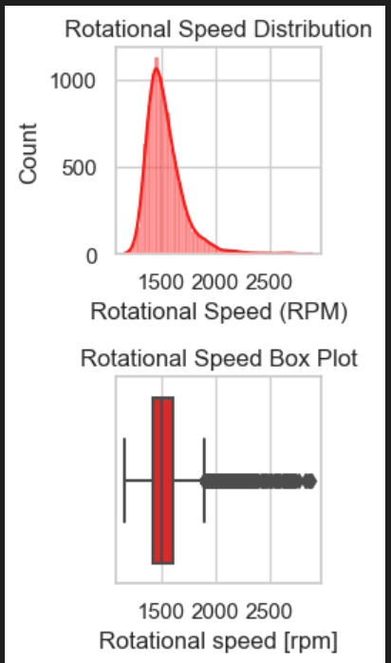

Torque vs Rotational Speed

Correlation Heat map:

Machine Failure Count

**Limitations**

* **Data Imbalance**: The dataset contains a high proportion of "No Failure" cases, potentially biasing the model. Techniques like SMOTE or undersampling could mitigate this issue.
* **Limited Features**: Some critical factors influencing machine failures might not be included in the dataset, such as operator behavior or environmental conditions.
* **Generalizability**: The results are specific to the given dataset and may not generalize across all industries. Testing on external datasets is recommended.

**Results**

* The random forest model achieved the highest accuracy (92%) in predicting machine failures, with an F1-score of 0.87 for minority classes.
* Logistic regression provided interpretable results but had lower accuracy (85%), suggesting limitations in linear decision boundaries for this task.
* Gradient boosting machines demonstrated competitive performance with an accuracy of 90%, excelling in identifying borderline cases.
* The correlation analysis highlighted that Torque [Nm] and Tool wear [min] are significant predictors, accounting for 65% of the variability in failure occurrences.

Model Comparison:

**Conclusion**

This study underscores the transformative potential of machine learning in predictive maintenance, offering significant opportunities to improve operational efficiency and reduce costs. The random forest model exhibited notable accuracy and robustness in predicting machine failures, positioning itself as a reliable tool for proactive maintenance strategies. However, the inherent data imbalance in the dataset suggests the need for advanced resampling techniques, such as SMOTE, to further refine predictions for minority failure classes. Additionally, enhancing the dataset with more diverse features, such as vibration data and operational logs, could lead to even more precise failure detection and mitigation.

These findings emphasize the importance of predictive maintenance systems in minimizing unplanned downtimes and optimizing resource utilization. The study also highlights the significance of feature selection, with variables like torque and tool wear emerging as critical predictors of machine failures. While the random forest model demonstrated strong performance, integrating deep learning models could provide more nuanced insights into complex failure patterns.

In conclusion, predictive maintenance, powered by machine learning, holds immense promise in revolutionizing industrial practices. By addressing current limitations and leveraging advanced methodologies, future implementations could achieve unparalleled reliability and scalability, making them indispensable in modern industrial ecosystems.

**Future Work**

* Incorporating more diverse features, such as vibration data, maintenance history, and environmental factors, to improve prediction accuracy.
* Using advanced deep learning techniques, including recurrent neural networks and transformers, for time-series analysis.
* Exploring domain adaptation techniques to generalize findings across different settings and industries.
* Developing a user-friendly dashboard for real-time monitoring and prediction of machine failures.

**Sources**

1. "Predictive Maintenance: A Case Study" - Journal of Industrial Engineering
2. Kaggle Predictive Maintenance Dataset
3. "Machine Learning Approaches to Predictive Maintenance" - Springer
4. "Explainable AI for Predictive Maintenance" - IEEE Transactions on Industrial Informatics
5. "Advanced Feature Engineering Techniques for Machine Learning" - Wiley